Heart Diaesae Analystis using Pandas and Seaborn

This Project mainly tells different people chorestorol level and bp level which shows us chances heart diaease .It shows their alcohol assumption ,diebetic or not ,they smoke or not and they are do exercise or not.In which age it shows different level of Bmi and sugar consumption.

Screenshot

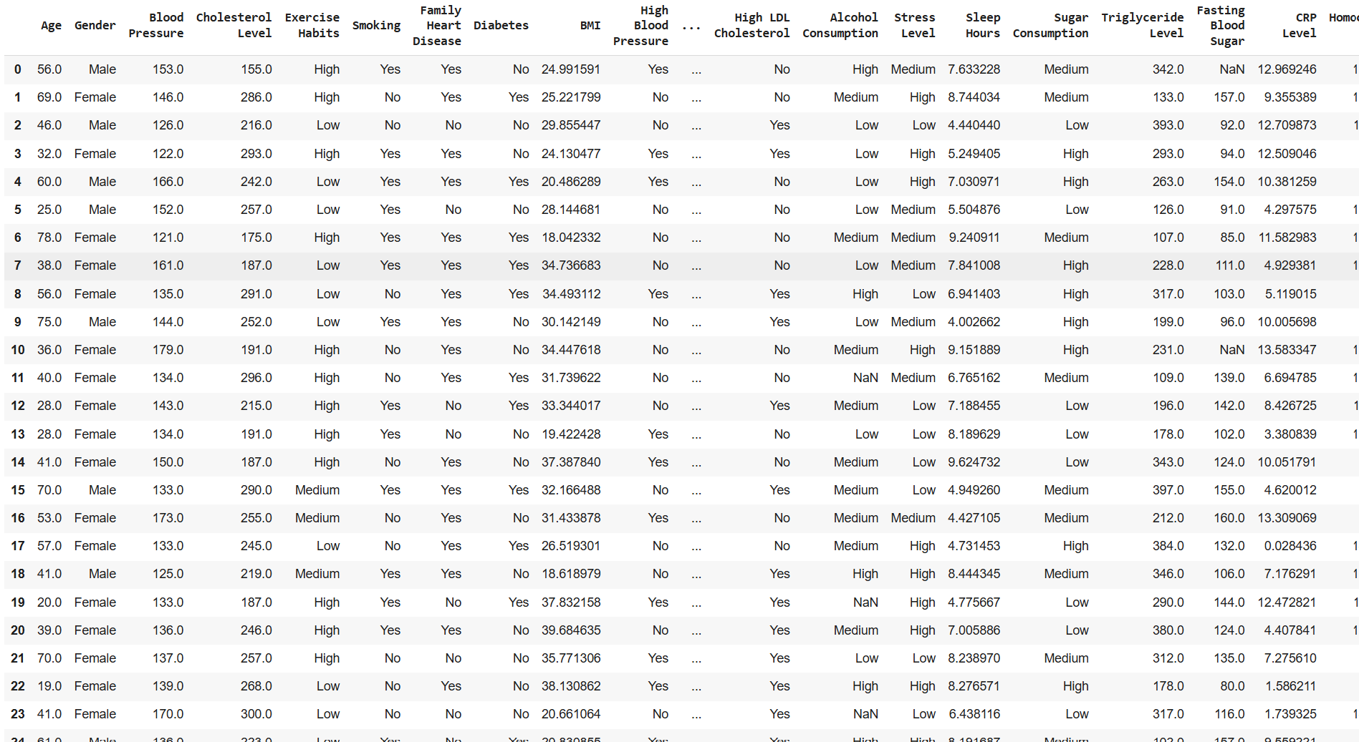

Conclusion

It shows analysis of heart diaease chances at different level of bmi rate and sugar level which gives us chances of heart dieases

